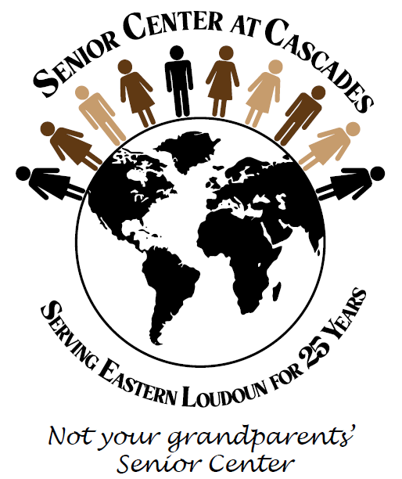
APPLICATION
CASCADES ARTS & CRAFTS FAIR
Saturday, October 19, 2024 – 9am-3pm
Senior Center at Cascades Advisory Board
21060 Whitfield Place Sterling, VA 20165

Deadline for space reservations is Friday, October 4
Reserve by September 20 for early bird price!
- One space $35.00 (max of two) - $40.00 after September 20
- One 2’ X 6’ table & two chairs included with your space
- Electricity (limited available - $5)

Set-up - 8:00–8:45am & Clean-up - 2:30PM–3:30PM

Send or drop off completed form and payment (Cash or Check). Checks payable to LCSCC Advisory Board. Contact the center at 571-258-3280 to pay by credit card. No refunds.

_________________________________ _______________________________
VENDOR (business & contact name) PHONE (cell and/or business #)

_____________________________________________________________________________________________________
EMAIL AND WEBSITE

_____________________________________________________________________________________
STREET ADDRESS

_______________________________ ___________ _________________
CITY STATE ZIP CODE

DESCRIBE ITEMS TO BE SOLD (Must be handcrafted/handmade by vendor)

_________________________________________________________________________________________________________

_________________________________________________________________________________________________________

___________________________________ + ________________________ = ________________________
1 or 2 SPACES x $35 ($40 after Sept 20) ELECTRICITY (Indoor $5) TOTAL AMOUNT DUE

NEW VENDORS – Must submit two photos: one of vendor making item & one of item(s) for sale. Digital files may be sent to brenda.davis@loudoun.gov.

SPECIAL NEEDS/REQUESTS:

__________________________________________________________________________________________

For further information, please call the center at 571-258-3280

All proceeds go to the Advisory Board of the Senior Center at Cascades
to enhance center programming and promote healthy aging

